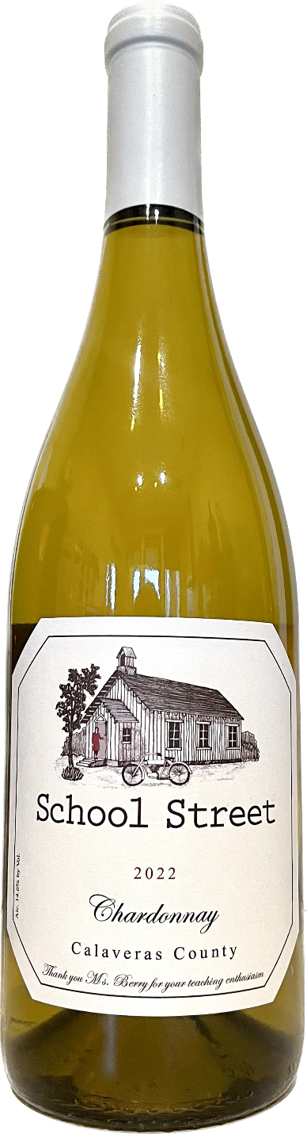

**2022 School Street Chardonnay**

**Tasting Notes**

Fruit from Indian Rock Vineyard and 6 Mile Vineyard in Calaveras County. Aged 6 months in a brand new 800-gallon Austrian cask. The cask adds flavor and body on a level that nicely balances this Chardonnay. Hints of lemon grass on the nose. Flavors of lemon. Medium bodied.

A nice white wine for spring.

**Wine Specs**

Alcohol: 14.6%

PH: 3.61

Acidity: 5.3

Appellation: Calaveras County

Pick date: 9/5/2022 & 9/6/2022

Winemaker: Matthew Hatcher

Release date: 2/9/2023

